# Request time off:

Step 1: from the home page click on the Time Worklet



Step 2: Click on Request Time Off

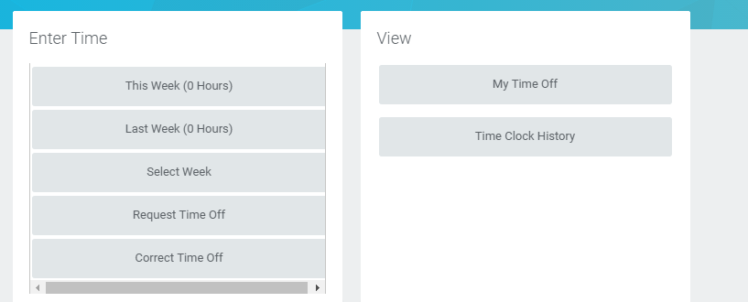

Step 3: Select the days on the calendar and click Request Time Off

Step 4: Enter the Time Off Type, daily quantity of hours requested and click submit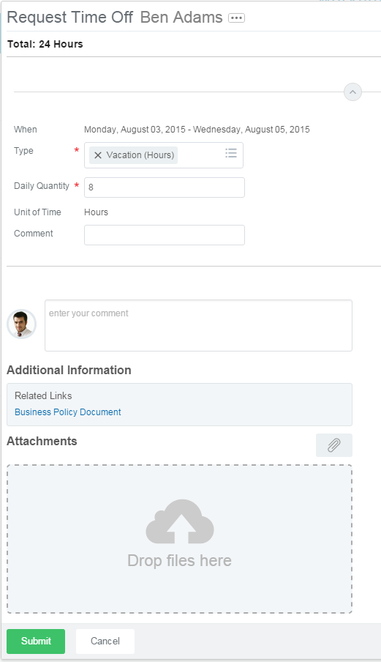

# Cancel/Correct time off:

Step 1: From the home page click on the Time Worklet



Step 2: Click on Correct Time Off

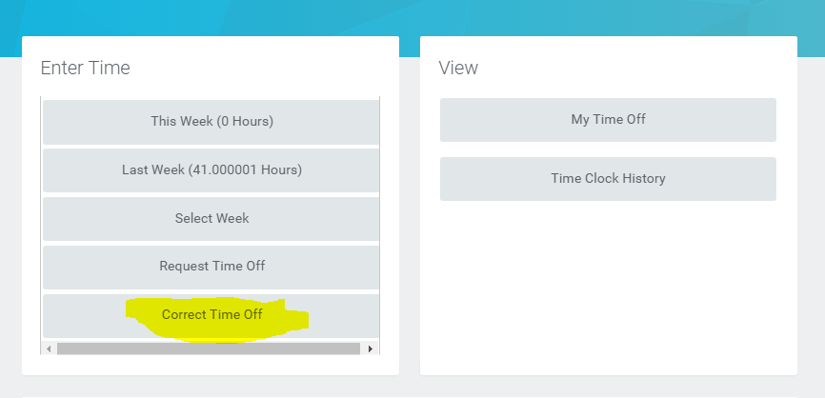

Step 3: Click on requested time off that you are cancelling.

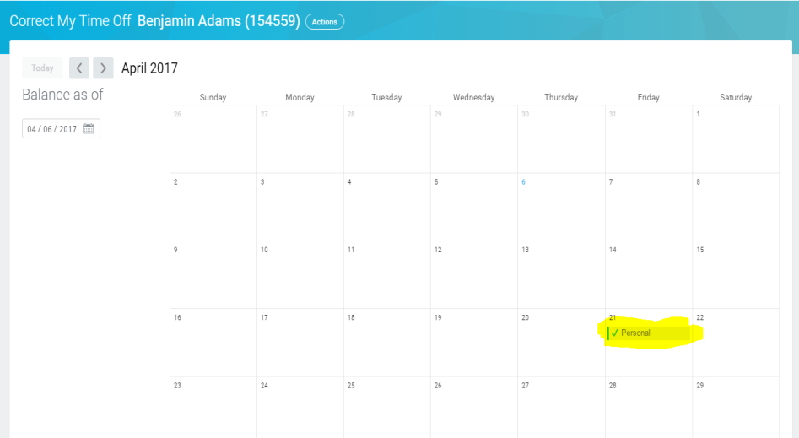

Step 4: Click on “delete/minimize” button next to selected time off request. Then submit.

